Dimensions / clearances for fitting a sectional door
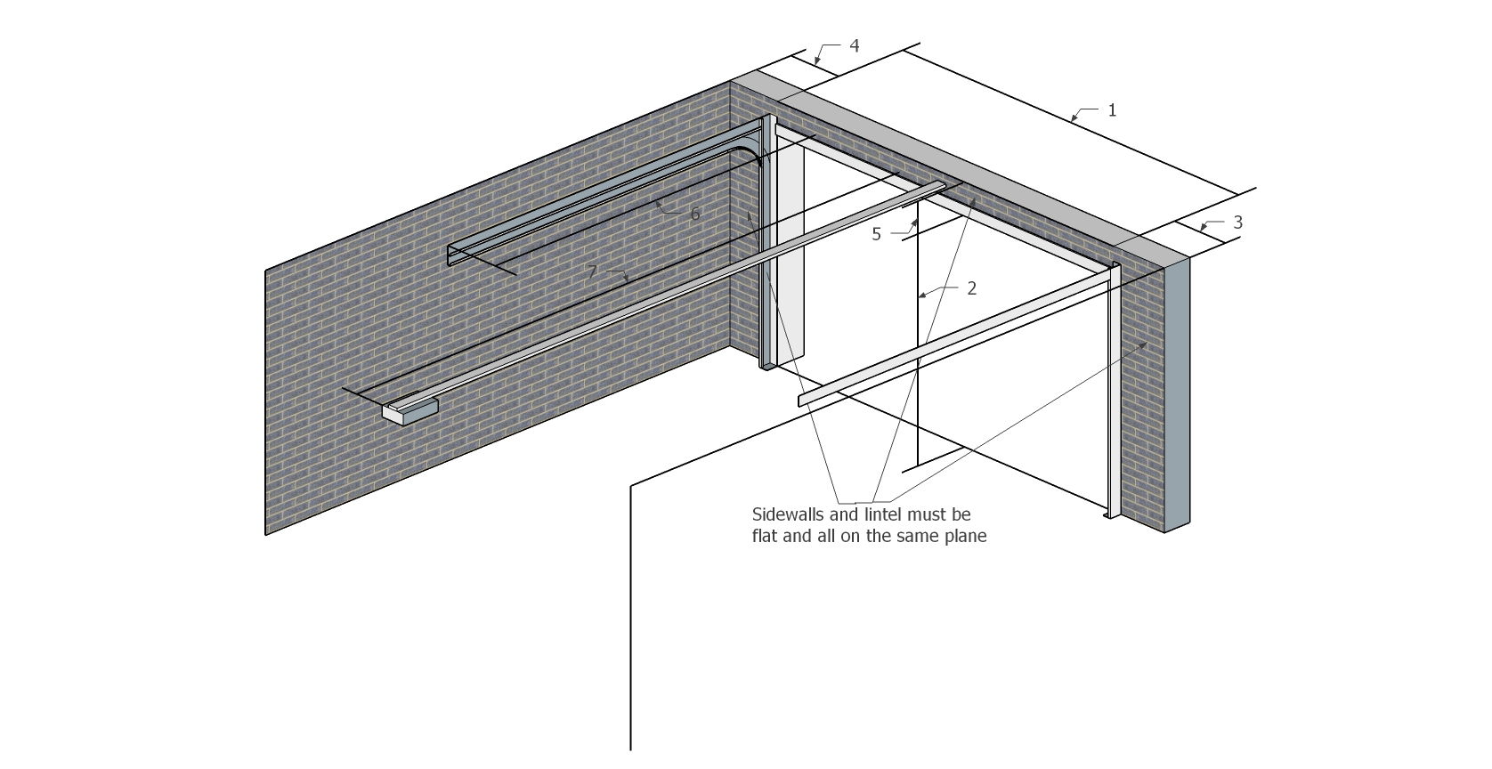

Rugby post frame assembly fits onto the rear of the masonry opening. It requires the sizes below for a 3048mm wide x 2125mm high Hormann or Alutech sectional door
1. Brick to brick width --------------------------------------------------------------------------- 3050mm
2. Floor to lintel height--------------------------------------------------------------------------- 2125mm
3. Uninterrupted right hand sideroom extending into garage for track length--- 120mm
4. Uninterrupted left hand sideroom extending into garage for track length----- 120mm
5. Headroom from underside of lintel to lowest point of ceiling--------------------- 160mm
6. Track depth into garage from back of brick opening--------------------------------- 2635mm
7. Motor boom depth into garage in centre of opening-------------------------------- 3400mm

