URL www.discount-garage-doors.co.uk/garage-door-fitters-Devon-Brixham-Tiverton

View fitters in other areas

GARAGE DOOR FITTER/INSTALLER DETAILS for Brixham, Tiverton, Sidmouth, Newton Abbot


Darren fits garage doors for our customers in South Devon

Image tag: Darren, our garage door fitter in South Devon
Name: Darren Age: 37
Years Experience of Fitting Garage Doors/Auto Kits etc: 20 years

Area covered for quality garage door installation / fitting: Brixham, Tiverton, Sidmouth, Newton Abbot

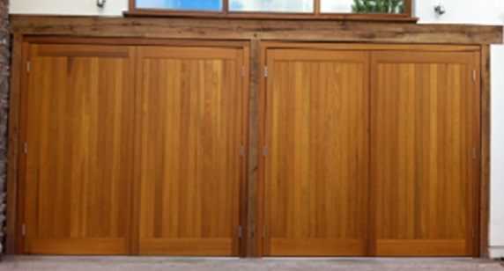

Insert this picture here – Cedar Door sidehinged fitted by D Chamberlain
Two pairs of Cedar Door Side-hinged doors fitted by Darren in Exeter
Image tag: Picture of pairs of Cedar Door sidehinged garage doors installed in Exeter
Arridge Garage Doors, est. 1989, are the only National garage door discounter to offer quality local garage door installation. Over a period of approximately 20 years, we have worked closely with garage door fitters, who we trust to do a good job at a fair price. To select the door of your choice, click on the Products button and follow the instructions. Over the last 10 years, Hormann sectional garage doors (make this a link to products http://www.discount-garage-doors.co.uk/buy-48-garage_door-Hormann+42+mm+insulated-par-45.html) and insulated roller doors (make this a link to products http://www.discount-garage-doors.co.uk/buy-174-garage_door-Hormann+Insulated-par-52.html) have become very popular.
Prices for installation only:
Single up and over: | £80 to £180
Double up and over: | £150 to £250
Insulated Roller Shutter – single | £150 to £250 (includes auto kit)
Insulated Roller Shutter – double | £200 to £300 (includes auto kit)
Single Skin Roller Shutter – single | £150 to £290 (includes auto kit where fitted)
Single Skin Roller Shutter – double | £220 to £350 (includes auto kit where fitted)
Single Sectional | £150 to £240
Double Sectional | £200 to £280
Motor - when fitted to the new door | £60 to £100
Motor - when fitted to your existing door | £TBA
Where applicable an old door etc. will be removed from site free of charge unless stated otherwise. Multiple orders will enjoy further discounts. A “double check” survey will be carried out on receipt of a firm order. See our How To Order Page .

Personal Details: Darren was born in Bolton, Lancashire and moved to Devon several years ago. He has been married for over 20 years and has two children. Darren plays Golf as often as possible (or as often as his Wife lets him!). Darren trains installers and warranty engineers for Wessex Garage Doors. He has a mechanical mind and enjoys challenging jobs. We can quote Darren as saying: “I always take pride in my work and carry out installations as though it is for myself”.
On receipt of a firm order, Darren will carry out a full survey. In order to quote you accurately on the garage door(s) of your choice, please complete the self survey form (make this a link http://www.discount-garage-doors.co.uk/printpage-survey.html) and phone for quality, unbiased help and advice and a very competitive garage door quotation. Telephone 01691 670394. If you prefer to e-mail us using the Contact Us (make this a link http://www.discount-garage-doors.co.uk/contact1.html) form, please give as many details as possible and ask all the questions you would like to have answered.
Testimonials:
“Many thanks. Very good job.” Kerry Boyes
Areas also covered for all aspects of garage doors and roller doors;
Tavistock, Plympton, Ivybridge, Brixham, Paignton, Dartmouth, Okehampton, Dawlish, Sidmouth, Horiton, Budleigh Salterton, Saltash, Newquay, St.Austell, Padstow, Wadebridge, Falmouth, Truro, Penzance, Redruth, Helston

Title tags: Garage door installation / fitting Brixham Tiverton Sidmouth Newton Abbot
Description tags: Quality garage door installation / fitting in Brixham, Tiverton, Sidmouth, Newton Abbot by Darren, who has been installing garage doors in the South West for over 20 years.

